Phase 3 notes
Background research notes
- Implement strength of opposition performance
- Laplacian model

Features of Laplacian:
- Data input: performance metrics
- Graph construction: Euclidean distances between team metrics build similarity graph
- Laplacian Eigenmap: dimensionality reduction to convert complex data to lower dimensional space to identify clusters
- Fiedler vector: algorithm bisects the fiedler vector (smallest non-zero eigenvector of Laplacian matrix) – separates dominant teams from weaker ones

Phase flow
1: generic ML models
2: domain-specific statistical model
3: shift from poisson assumptions of:
- Mean = variance
- Independent scoring
- Thin tails
What happens if we relax these assumptions? Investigate whether Poisson’s assumptions limit predictive performance
Does a more flexible goal distribution improve predictions?

Also implement negative binomial model -> discrete and allows variance > mean.
IF BINOMIAL IMPROVES: “allowing for overdispersion via a negative binomial model improve prediction performance, suggesting goal variability exceeds poisson assumptions”
IF LAPLACE DOESN’T: “did not improve performance, indicating that continuous heavy-tailed distributions are less suitable for discrete goal data”
Also implement Bayesian poisson as it has strengths as distributions rather than discrete values:
- Handles uncertainty properly
  - Early season - Few matches -> high uncertainty
  - Late season – more data -> confident estimates
- Prevents overfitting
  - Current model reacts strongly to noise
  - Bayesian shrinks estimates toward prior
- Advanced statistical model
Model differentials
- Poisson
  - Assumes:
    - Mean = variance
  - Implication:
    - Events are independent
    - No overdispersion (extra randomness)
  - Limitation:
    - Real football data has:
      - More variance than mean (overdispersion)
      - Occasional extreme scorelines
      - Correlation between teams’ goals
- Laplacian
  - Distribution: double exponential
  - Shape: sharper peak + heavier tails than Gaussian
  - Assumes:
    - Errors follow a laplace distribution
    - More tolerance for outliers/extreme scores
  - Addresses:
    - Poisson underestimates:
      - Big wins
      - Rare deviations
  - Laplace is continuous, football goals are discrete
  - Not directly replacing poisson – modelling goal deviations or discretising laplace – WHY IT’S A BASELINE
- Negative Binomial
  - Extension of poisson
  - Adds a dispersion parameter k
  - Assumes:
    - Mean != variance
    - Variance = mean + (mean^2 / k)
  - Addresses:
    - Overdispersion (very common)
  - Most theoretically justified upgrade
  - Often used in sports analytics
- Bayesian Poisson
  - Instead of fixed attac/defence strengths, use distributions over strengths
  - Assumes:
    - Parameters are uncertain and evolve over time
  - Addresses:
    - Early-season noise
    - Overfitting to small samples
    - Sudden changes in team strength
  - Don’t just estimate attack = 1.2, estimate attack ~ distribution (mean + uncertainty)
- Implementation:
  - Negative binomial -> laplace -> Bayesian
    - Laplace serves as a conceptual baseline, implemented after binomial due to practical challenges in discretising continuous distributions for count data
Actual implementation
- Binomial – relax variance assumption:
  - Loading of data same as phase 2
  - Everything up to expected goals calc is the same – data -> strengths -> xG
  - Poisson model becomes binomial, goals ~ Negative Binomial(u,k), variance = u + u^2 / k
  - USE TRAINING DATA TO PREDICT K, CALC MEAN AND VARIANCE FROM TRAINING DATA
    - Training data is past matches -> estimate team strengths -> predict next match
    - Use actual goals for mean and variance as it directly measures overdispersion in reality
    - xG already smoothed and underestimates variance
    - adjusted rolling_strengths_weighted to store k, mean and variance
      - prevents duplication of code
    - if mean > variance, use high k for low dispersion so it approximates like poisson
  - negative binomial is slightly better with log loss and brier score, same in accuracy -> what theory predicts CONCLUSION
  - overdispersion exists, but its impact on predictive performance is limited
  - NB noticeably better early season -> variance effect
  - Later seasons they are very close
  - “primary gains in predictive performance come from improved parameter estimation (recency weighting), rather than relaxing poisson variance assumption”
  - Evaluation.py is the same as well for negative binomial
- Laplacian – what if the entire distribution assumption is wrong:
  - Not aiming to beat poisson
    - Testing if heavy-tailed distribution improves modelling of football scores
  - Main challenge is to convert laplace, a continuous distribution, into discrete goal probabilities
  - Goals = mean + laplace noise
  - P(x) = integral Laplace PDF over [x – 0.5, x + 0.5]
  - Interpretable, minimal assumptions, consistent with pipeline
  - DON’T:
    - Round laplace samples
    - Treat as discrete directly
    - Overcomplicate with mixtures
  - Expected behaviour compared to poisson:
    - More probability at :
      - 0 goals
      - High goals (4+)
    - Flatter distribution
    - ^^ similar effect to NB, but different mechanism
  - Use b as correction, b = sqrt(variance/2)
  - Use laplace.cdf (cumulative density function) for discretisation
  - If h, a == 0, P(x) = 0.5
    - if not, 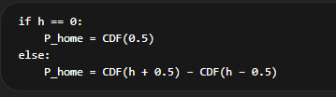
- Bayesian – “what if the parameters themselves are uncertain”:
  - Instead of fixed attack/defence strengths, have them as distributions
  - Likely to:
    - Improve early-season predictions
    - Reduce noise from small samples
  - Is uncertainty in parameter estimation more important than changing the goal distribution?
  - Implemented with recursive / smoothed parameter updates
  - For each team track:
    - Attack_mean
    - Attack_variance
    - Defence_mean
    - Defence_variance
  - Update ^^ after each match
  - Pipeline: past matches -> update team distributions -> compute xg -> poisson distribution -> score matrix
  - Uses poisson distribution as we are looking at parameter estimation effect, not distribution
  - 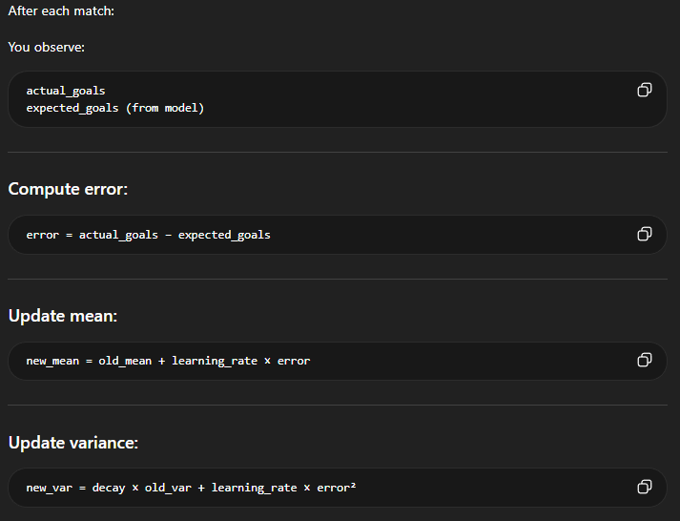
  - Large errors -> increase uncertainty
  - Consistent performance -> reduce uncertainty
  - High learning rate -> reacts quickly (noisy), low learning rate -> stable (slow adaptation)
  - Cant use rolling strengths csv, as need mean for home and away teams for strengths, still rolling but calculated in the same file as the model
  - ^^ strengths are no longer static
  - Error = actual goals – calculated xg
  - Xg calculation = mean_xg * mean_xga / league_avg_xg * attack_mean * defence_mean
  - CONCLUSION:
    - Turned out less accurate
    - Designed to improve parameter estimation, but phase 2 model already did this well through rolling strengths and stable estimates
      - bayesian adds extra noise not new information
- “primary limitation of football prediction models lies in feature representation rather than distributional assumptions or parameter estimation frameworks
- Plot line graph of log loss across seasons
  - Better accuracy at 2018
  - Weighted poisson tends to be best, NB/laplace similar, bayesian not consistently better
- Plot bar graph of average log losses and brier scores
  - “weighted poisson model achieves lowest, while alternative distributions such as NB and Laplace provide no significant improvement. Bayesian model performs worse, indicating that additional complexity does not necessarily enhance predictive accuracy”
- Plot improvement graphs of log loss and brier score
  - Laplace and nb slightly better, bayesian much worse
- “changing goal distribution (NB,laplace) has minimal impact”
- “bayesian updating does not outperform rolling estimation”
- “primary driver of performance is accurate estimation of expected goals rather than distributional assumptions”
- “while machine learning models provide a flexible framework for prediction, domain-specific probabilistic models based on expected goals offer superior performance.”

